190905513 LAB 03 MOHAMMAD DANISH EQBAL

BATCH A3 CONSTRUCTION OF TOKEN GENERATOR SECTION A

SAMPLE EXERCISE:

Write a program in ‘C’ to identify the arithmetic and relational operators from the given input ‘C’ file.

Program:
//Program in ‘C’ to identify the arithmetic and relational operators from the given input ‘C’ file.
#include<stdio.h>
#include<string.h>
#include<stdlib.h>
int main()
{
char c,buf[10];
FILE *fp=fopen("digit.c","r");
c = fgetc(fp);
if (fp == NULL)
{
printf("Cannot open file \n");
exit(0);
}
while(c!=EOF)
{
int i=0;
buf[0]='\0';
if(c=='=')
{
buf[i++]=c;
c = fgetc(fp);
if(c=='=')
{
buf[i++]=c;
buf[i]='\0';
printf("\n Relational operator : %s",buf);
}
else
{
buf[i]='\0';
printf("\n Assignment operator: %s",buf);
}
}
else
{
if(c=='<'||c=='>'||c=='!')
{
buf[i++]=c;
c = fgetc(fp);
if(c=='=')
{
buf[i++]=c;
}
buf[i]='\0';
printf("\n Relational operator : %s",buf);
}
else
{
buf[i]='\0';
}
}
c = fgetc(fp);
} }

Output:
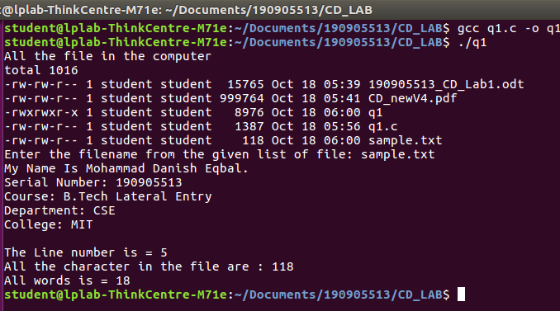

LAB EXERCISES:

1. Design a lexical analyzer which contains getNextToken( ) for a simple C program to create a structure of token each time and return, which includes row number, column number and token type. The tokens to be identified are arithmetic operators, relational operators, logical operators, special symbols, keywords, numerical constants, string literals and identifiers. Also, getNextToken() should ignore all the tokens when encountered inside single line or multiline comment or inside string literal. Preprocessor directive should also be stripped.

Program:
#include <stdio.h>
#include <stdlib.h>
#include <string.h>
#include <ctype.h>

#define FILEINPUT "digit.c"

struct token
{
char lexeme[64];
int row,col;
char type[20];
};

static int row=1,col=1;
char buf[2048];

const char specialsymbols[]={'?',';',':',','};
const char *keywords[] = {"const", "char", "int","return","for", "while", "do",
"switch", "if", "else","unsigned", "case", "break" };

const char arithmeticsymbols[]={'*'};

int isKeyword(const char *str)
{
for(int i=0;i<sizeof(keywords)/sizeof(char*);i++)
{
if(strcmp(str,keywords[i])==0)
{
return 1;
}
}
return 0;
}

int charBelongsTo(int c,const char *arr)
{
int len;

if(arr==specialsymbols)
{
len=sizeof(specialsymbols)/sizeof(char);
}

else if(arr==arithmeticsymbols)
{
len=sizeof(arithmeticsymbols)/sizeof(char);
}

for(int i=0;i<len;i++)
{
if(c==arr[i])
{
return 1;
}
}

return 0;
}

void fillToken(struct token *tkn,char c,int row,int col, char *type)
{
tkn->row=row;
tkn->col=col;
strcpy(tkn->type,type);
tkn->lexeme[0]=c;
tkn->lexeme[1]='\0';
}

void newLine()
{
++row;
col=1;
}

struct token getNextToken(FILE *f1)
{
int c;
struct token tkn=
{
.row=-1
};

int gotToken=0;

while(!gotToken && (c=fgetc(f1))!=EOF)
{
if(charBelongsTo(c,specialsymbols))
{
fillToken(&tkn,c,row,col,"SS");
gotToken=1;
++col;
}

else if(charBelongsTo(c,arithmeticsymbols))
{
fillToken(&tkn,c,row,col,"ARITHMETIC OPERATOR");
gotToken=1;
++col;
}

else if(c=='(')
{
fillToken(&tkn,c,row,col,"LB");
gotToken=1;
++col;
}

else if(c==')')
{
fillToken(&tkn,c,row,col,"RB");
gotToken=1;
++col;
}

else if(c=='{')
{
fillToken(&tkn,c,row,col,"LC");
gotToken=1;
++col;
}

else if(c=='}')
{
fillToken(&tkn,c,row,col,"RC");
gotToken=1;
++col;
}

else if(c=='+')
{
int d=fgetc(f1);

if(d!='+')
{
fillToken(&tkn,c,row,col,"ARITHMETIC OPERATOR");
gotToken=1;
++col;
fseek(f1,-1,SEEK_CUR);
}

else
{
fillToken(&tkn,c,row,col,"UNARY OPERATOR");
strcpy(tkn.lexeme,"++");
gotToken=1;
col+=2;
}
}

else if(c=='-')
{
int d=fgetc(f1);

if(d!='-')
{
fillToken(&tkn,c,row,col,"ARITHMETIC OPERATOR");
gotToken=1;
++col;
fseek(f1,-1,SEEK_CUR);
}

else
{
fillToken(&tkn,c,row,col,"UNARY OPERATOR");
strcpy(tkn.lexeme,"--");
gotToken=1;
col+=2;
}
}

else if(c=='=')
{
int d=fgetc(f1);

if(d!='=')
{
fillToken(&tkn,c,row,col,"ASSIGNMENT OPERATOR");
gotToken=1;
++col;
fseek(f1,-1,SEEK_CUR);
}

else
{
fillToken(&tkn,c,row,col,"RELATIONAL OPERATOR");
strcpy(tkn.lexeme,"==");
gotToken=1;
col+=2;
}
}

else if(isdigit(c))
{
tkn.row=row;
tkn.col=col++;
tkn.lexeme[0]=c;

int k=1;

while((c=fgetc(f1))!=EOF && isdigit(c))
{
tkn.lexeme[k++]=c;
col++;
}

tkn.lexeme[k]='\0';
strcpy(tkn.type,"NUMBER");
gotToken=1;
fseek(f1,-1,SEEK_CUR);
}

else if(c == '#')
{
while((c = fgetc(f1)) != EOF && c != '\n');
newLine();
}

else if(c=='\n')
{
newLine();
c = fgetc(f1);

if(c == '#')
{
while((c = fgetc(f1)) != EOF && c != '\n');
newLine();
}

else if(c != EOF)
{
fseek(f1, -1, SEEK_CUR);
}
}

else if(isspace(c))
{
++col;
}

else if(isalpha(c)||c=='_')
{
tkn.row=row;
tkn.col=col++;
tkn.lexeme[0]=c;
int k=1;

while((c=fgetc(f1))!= EOF && isalnum(c))
{
tkn.lexeme[k++]=c;
++col;
}

tkn.lexeme[k]='\0';

if(isKeyword(tkn.lexeme))
{
strcpy(tkn.type,"KEYWORD");
}

else
{
strcpy(tkn.type,"IDENTIFIER");
}

gotToken=1;
fseek(f1,-1,SEEK_CUR);
}

else if(c=='/')
{
int d=fgetc(f1);
++col;//Do we check EOF here?

if(d=='/')
{
while((c=fgetc(f1))!= EOF && c!='\n')
{
++col;
}

if(c=='\n')
{
newLine();
}
}

else if(d=='*')
{
do
{
if(d=='\n')
{
newLine();
}

while((c==fgetc(f1))!= EOF && c!='*')
{
++col;

if(c=='\n')
{
newLine();
}
}

++col;
}while((d==fgetc(f1))!= EOF && d!='/' && (++col));
++col;
}

else
{
fillToken(&tkn,c,row,--col,"ARITHMETIC OPERATOR");
gotToken=1;
fseek(f1,-1,SEEK_CUR);
}
}

else if(c == '"')
{
tkn.row = row;
tkn.col = col;
strcpy(tkn.type, "STRING LITERAL");
int k = 1;
tkn.lexeme[0] = '"';

while((c = fgetc(f1)) != EOF && c != '"')
{
tkn.lexeme[k++] = c;
++col;
}

tkn.lexeme[k] = '"';
gotToken = 1;
}

else if(c == '<' || c == '>' || c == '!')
{
fillToken(&tkn, c, row, col, "RELATIONAL OPERATOR");
++col;
int d = fgetc(f1);
if(d == '=')
{
++col;
strcat(tkn.lexeme, "=");
}

else
{
if(c == '!')
{
strcpy(tkn.type, "LOGICAL OPERATOR");
}

fseek(f1, -1, SEEK_CUR);
}

gotToken = 1;
}

else if(c == '&' || c == '|')
{
int d = fgetc(f1);

if(c == d)
{
tkn.lexeme[0] = tkn.lexeme[1] = c;
tkn.lexeme[2] = '\0';
tkn.row = row;
tkn.col = col;
++col;
gotToken = 1;
strcpy(tkn.type, "LOGICAL OPERATOR");
}

else
{
fseek(f1, -1, SEEK_CUR);
}
++col;
}

else
{
++col;
}
}
return tkn;
}

int main()
{
FILE *f1=fopen(FILEINPUT,"r");
if(f1==NULL)
{
printf("Error! File cannot be opened!\n");
return 0;
}

struct token tkn;
while((tkn=getNextToken(f1)).row!=-1)
{
printf("<%s, %d, %d>\n",tkn.type, tkn.row,tkn.col);
}

fclose(f1);
}

Output:
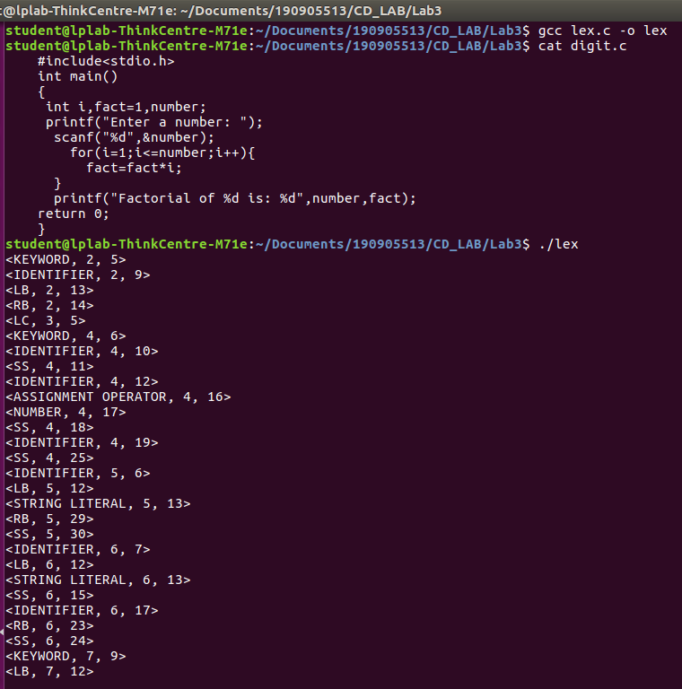
//(1/3)

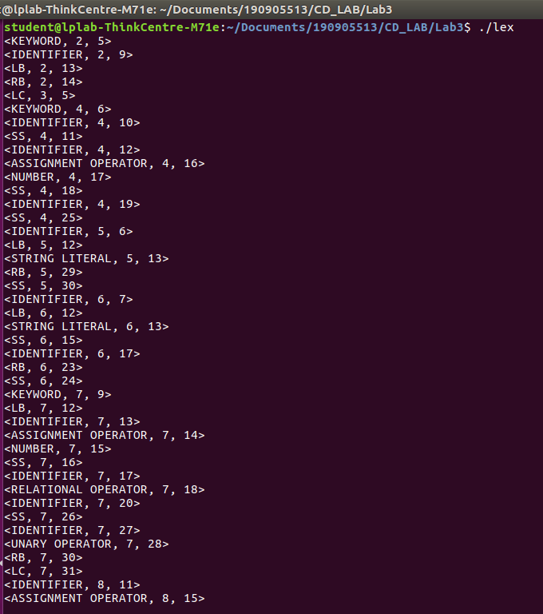
//(2/3)

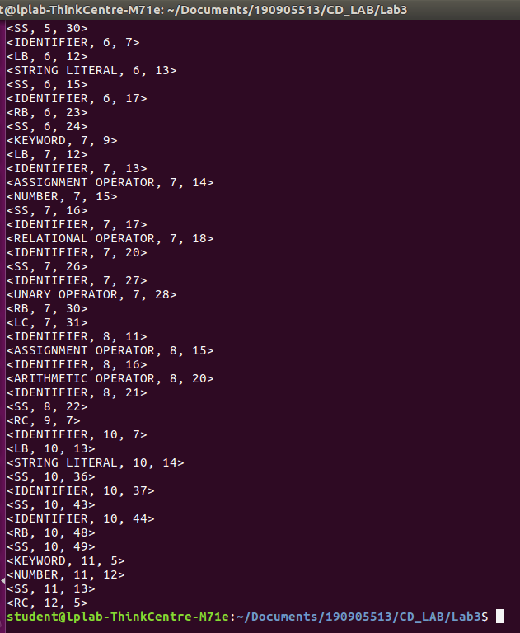
//(3/3)

